

Agri Twin – Digital Twin Platform for Precision Farming and Crop Health Prediction

CASE STUDY ANALYSIS REPORT

Submitted in the partial fulfilment for the Course of

CSA1012 – Software Engineering

to the award of the degree of

BACHELOR OF TECHNOLOGY

Submitted by
Paleru Dharani Govardhan (192525280)

UNDER THE SUPERVISION OF
Dr. K. Anita Davamani

SIMATS ENGINEERING
Saveetha Institute of Medical and Technical Sciences
Chennai-602105
July-2026
ACKNOWLEDGEMENT

We would like to express our heartfelt gratitude to all those who supported and guided us throughout the successful completion of our Capstone Project. We are deeply thankful to our respected Founder and Chancellor, Dr. N.M. Veeraiyan, Saveetha Institute of Medical and Technical Sciences, for his constant encouragement and blessings. We also express our sincere thanks to our Pro-Chancellor, Dr. Deepak Nallaswamy Veeraiyan, and our Vice-Chancellor, Dr. S. Suresh Kumar, for their visionary leadership and moral support during the course of this project.

We are truly grateful to our Director, Dr. Ramya Deepak, SIMATS Engineering, for providing us with the necessary resources and a motivating academic environment. Our special thanks to our Principal, Dr. B. Ramesh for granting us access to the institute’s facilities and encouraging us throughout the process. We sincerely thank our Head of the Department, Dr K. Anita Davamani for his continuous support, valuable guidance, and constant motivation.

We are especially indebted to our guide Dr K. Anita Davamani for his creative suggestions, consistent feedback, and unwavering support during each stage of the project. We also express our gratitude to the Project Coordinators, Review Panel Members (Internal and External), and the entire faculty team for their constructive feedback and valuable inputs that helped improve the quality of our work. Finally, we thank all faculty members, lab technicians, our parents, and friends for their continuous encouragement and support.

Signature With Student Name
P. Dharani Govardhan (192525280)

Abstract

# ABSTRACT

Agriculture plays a vital role in ensuring food security and supporting the economy, but traditional farming methods often face challenges such as crop diseases, unpredictable weather conditions, water scarcity, and inefficient resource management. These problems can reduce crop productivity and increase farming costs. To overcome these challenges, modern technologies such as Artificial Intelligence (AI), Internet of Things (IoT), and Digital Twin technology can be used to improve agricultural practices.

The proposed project, **AgriTwin – Digital Twin Platform for Precision Farming and Crop Health Prediction**, is an intelligent farming solution that creates a virtual representation of an agricultural field using real-time data collected from IoT sensors. The system continuously monitors environmental conditions such as soil moisture, temperature, humidity, and weather information. This data is analyzed using AI and Machine Learning algorithms to predict crop diseases, recommend smart irrigation schedules, and suggest suitable fertilizer usage.

The platform provides farmers with a centralized web or mobile dashboard to monitor crop health, receive alerts, and make informed decisions. By integrating Digital Twin technology with AI, IoT, and cloud computing, the proposed system improves crop productivity, reduces water and fertilizer wastage, lowers operational costs, and promotes sustainable precision farming.

Overall, AgriTwin demonstrates how modern software engineering technologies can be applied to agriculture to support efficient farm management and enhance the quality and productivity of crops.

INDEX
S.no | Topic | Page No.
1 | INTRODUCTION | 5
2 | PROBLEM ANALYSIS | 7-8
3 | OBJECTIVES | 9
4 | SCOPE | 10-12
5 | STAKEHOLDER ANALYSIS | 13-14
6 | EXISTING SYSTEM | 15-16
7 | PROPOSED SYSTEM | 17
8 | REFERENCE | 18

CHAPTER-1
INTRODUTION
  - Introduction
Agriculture is one of the most important sectors in the world as it provides food, employment, and supports the economy. In India, millions of people depend on farming for their livelihood. However, traditional farming methods mainly rely on manual observation and experience, making it difficult to detect crop diseases, pest attacks, and water shortages at an early stage. This often leads to reduced crop yield, increased farming costs, and wastage of resources.
With the advancement of technology, modern agriculture has started using technologies such as the Internet of Things (IoT), Artificial Intelligence (AI), Machine Learning (ML), cloud computing, drones, and weather forecasting systems. These technologies help farmers collect real-time information about soil, crops, and weather conditions, allowing them to make better farming decisions.
The proposed project, Agri Twin – Digital Twin Platform for Precision Farming and Crop Health Prediction, is designed to improve agricultural productivity using Digital Twin technology. A Digital Twin is a virtual representation of a real agricultural field that continuously receives real-time information from sensors and other data sources. This allows farmers to monitor crop conditions without physically inspecting every part of the farm.
The Agri Twin platform combines IoT sensors, weather data, and AI-based prediction models to monitor soil moisture, temperature, humidity, crop health, and disease risks. Based on the collected data, the system provides recommendations for irrigation, fertilizer application, and pest management. This helps farmers make quick and accurate decisions, reduce resource wastage, and improve crop yield.
  - Background of the Study
Modern agriculture is moving towards Precision Farming, where technology is used to monitor and manage crops efficiently. Instead of applying water and fertilizers equally across the entire field, Precision Farming uses real-time data to provide resources only where they are needed.
Digital Twin technology supports this approach by creating a virtual model of the farm. It continuously updates the farm's condition using sensor data and weather information. Artificial Intelligence further analyses this data to predict crop diseases, estimate irrigation requirements, and improve overall farm management.
  - Need for the Project
Farmers today face several challenges, including unpredictable weather conditions, water scarcity, crop diseases, pest attacks, and improper use of fertilizers. Traditional farming methods mainly depend on manual observation, which makes it difficult to detect these problems at an early stage. As a result, farmers often experience reduced crop yield, increased production costs, and loss of valuable resources.

The proposed AgriTwin platform is developed to overcome these challenges by using modern technologies such as Digital Twin, Internet of Things (IoT), Artificial Intelligence (AI), and Machine Learning (ML). The system continuously collects real-time data from sensors and weather services to monitor the health of crops and the condition of the farm. AI algorithms analyze this data to predict diseases, recommend irrigation schedules, and suggest fertilizer usage based on the current farm conditions.

By providing accurate information and timely recommendations, the AgriTwin platform helps farmers make better decisions, improve crop productivity, reduce resource wastage, and promote sustainable farming practices. It also serves as a centralized platform where farmers can monitor all important agricultural information in one place.

Chapter Summary

This chapter introduced the importance of agriculture and explained the limitations of traditional farming methods. It discussed how modern technologies such as IoT, Artificial Intelligence, Machine Learning, and Digital Twin technology are transforming agriculture into a smart and data-driven process. The chapter also highlighted the need for developing the AgriTwin platform to improve crop monitoring, disease prediction, irrigation management, and overall farm productivity.

The AgriTwin platform aims to provide farmers with a complete digital solution that supports precision farming through real-time monitoring and intelligent decision-making. The next chapter presents the problem analysis by identifying the existing challenges, objectives, and scope of the proposed system.

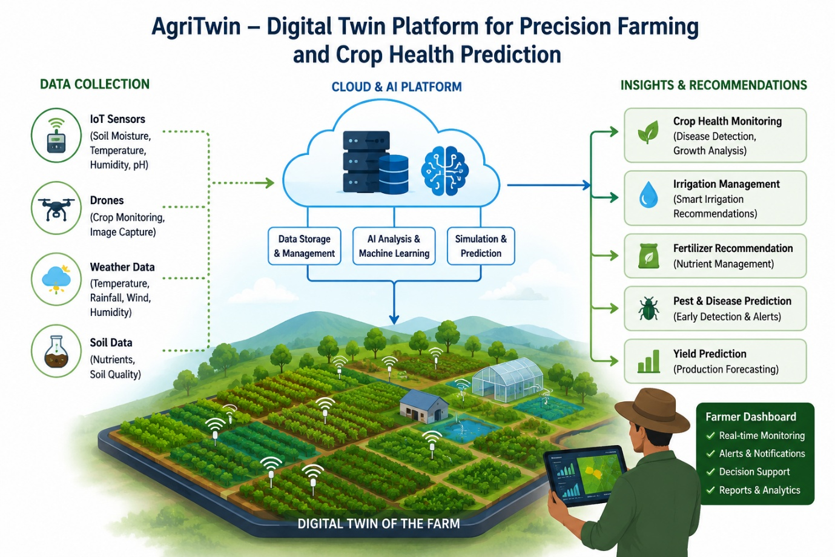

CHAPTER-2

Problem Identification and Analysis

2.1 Description of the Problem
Agriculture is the backbone of many countries and plays a major role in food production and economic growth. However, farmers continue to face several challenges due to changing weather conditions, crop diseases, pest attacks, water scarcity, and inefficient resource management. Traditional farming methods mainly rely on manual observation and experience, making it difficult to identify problems at an early stage. This often results in lower crop productivity and higher farming costs.

The AgriTwin project addresses these issues by providing a Digital Twin platform integrated with Artificial Intelligence (AI), Internet of Things (IoT), and weather forecasting services. The system continuously monitors farm conditions, predicts potential risks, and provides timely recommendations to support better decision-making. This chapter analyzes the existing problems in agriculture and explains the need for the proposed solution.
2.2 Problem Statement
Many farmers still depend on traditional farming techniques where crop monitoring is done manually. This approach is time-consuming and often fails to identify crop diseases, pest infestations, and soil problems during the early stages. Farmers also face difficulties in determining the correct amount of water and fertilizers required for healthy crop growth.
In addition, environmental factors such as unpredictable rainfall, extreme temperatures, and changing climate conditions make farming more challenging. The lack of a centralized system to monitor all farm-related information further reduces farming efficiency. Therefore, there is a need for an intelligent platform that can continuously monitor agricultural fields, analyze real-time data, and provide accurate recommendations for improving crop health and productivity.

2.3 Existing System

The existing farming system mainly depends on manual field inspections and the personal experience of farmers. Crop conditions are checked by physically visiting the farm, which requires significant time and effort. Information from weather reports, soil testing, and crop monitoring is usually collected separately and is not integrated into a single platform.

Most traditional systems do not provide real-time monitoring or predictive analysis. As a result, farmers often detect diseases and pest attacks only after visible damage has occurred. Water and fertilizers are applied based on assumptions rather than actual field conditions, leading to resource wastage and reduced crop yield.2.4 Supporting Data/Research
Research studies and industry reports show that efficient file system design significantly improves system performance, storage management, and data reliability. Modern file systems such as NTFS, ext4, and APFS include advanced features like journaling, caching, and encryption to reduce data corruption and improve security. Studies on distributed and cloud-based storage systems also demonstrate the growing need for scalable and fault-tolerant file systems. Experimental research indicates that optimized file allocation and indexing techniques can reduce file access time and improve overall system efficiency in both personal and enterprise computing environments.

2.4 Limitations of Existing System
The existing agricultural system has several limitations that affect farming efficiency and productivity. Some of the major limitations are:

• Manual crop monitoring requires significant time and labour.
• Diseases and pest attacks are detected only after visible symptoms appear.
• Excessive or insufficient irrigation leads to water wastage.
• Fertilizer usage is not optimized based on soil conditions.
• Weather information is not fully integrated into farming decisions.
• No centralized platform is available for monitoring the complete farm.
• Decision-making mainly depends on personal experience instead of data analysis.
• Lower crop productivity and increased farming costs.

2.5 Proposed System
The proposed AgriTwin platform is an intelligent Digital Twin system that combines IoT sensors, Artificial Intelligence, Machine Learning, weather forecasting, and cloud computing to improve agricultural productivity. The system continuously collects real-time information such as soil moisture, temperature, humidity, and weather conditions.

The collected data is analyzed using AI models to predict crop diseases, recommend irrigation schedules, and suggest fertilizer usage. A Digital Twin creates a virtual representation of the farm, allowing farmers to monitor crop conditions through an interactive dashboard. The platform provides timely alerts and recommendations, helping farmers make better decisions while reducing resource wastage and improving crop yield.

CHAPTER-3
OBJECTIVES AND SCOPE OF THE PROPOSED SYSTEM.
3.1 Introduction
The AgriTwin platform is designed to improve agricultural productivity by integrating Digital Twin technology, Artificial Intelligence (AI), Internet of Things (IoT), and cloud computing into a single system. The main objective of the project is to help farmers monitor crop health, predict diseases, optimize irrigation, and make data-driven decisions. This chapter describes the objectives of the proposed system and defines its scope and limitations.
3.2 Objectives of the Proposed System
The primary objective of the AgriTwin platform is to develop an intelligent Digital Twin system that enables real-time monitoring and management of agricultural fields. The specific objectives of the proposed system are:

• To continuously monitor farm conditions using IoT sensors.
• To create a Digital Twin of the agricultural field for real-time visualization.
• To predict crop diseases using Artificial Intelligence and Machine Learning.
• To provide smart irrigation recommendations based on soil moisture and weather conditions.
• To recommend suitable fertilizer usage according to soil health.
• To generate timely alerts and notifications for farmers.
• To improve crop productivity while reducing farming costs.
• To promote sustainable and precision farming practices.
3.3 Scope of the Proposed System
The AgriTwin platform is intended for farmers, agricultural organizations, and researchers who require an intelligent solution for crop monitoring and farm management. The system collects real-time information from IoT sensors, weather forecasting services, and image analysis to provide accurate recommendations.
The platform supports crop health monitoring, disease prediction, irrigation management, fertilizer recommendation, and yield prediction through a centralized dashboard. Farmers can access the system using web or mobile applications to monitor their fields from anywhere.
Although the system provides valuable predictions and recommendations, final farming decisions remain under the control of the farmer. The platform is designed to assist decision-making rather than replace human expertise.storage and retrieval of data. Modern techniques such as journaling, caching, and indexing are incorporated to improve system performance and reduce the risk of data corruption. The solution also emphasizes scalability and efficient space utilization to support growing storage demands in modern computing environments.

3.5 Benefits of the Proposed System

The proposed system offers several benefits to farmers and the agricultural sector:

• Improves crop yield and quality.

• Reduces water and fertilizer wastage.

• Enables early disease detection.

• Supports data-driven farming decisions.

• Reduces operational costs.

• Saves time through automated monitoring.

• Increases farming efficiency.

• Encourages sustainable agricultural practices.
3.6 Limitations of the Proposed System
Although the AgriTwin platform provides several advantages, it has certain limitations

CHAPTER - 4

SYSTEM DESIGN AND REQUIREMENTS

4.1 Introduction

The design of a software system plays an important role in ensuring that it meets user requirements effectively. The AgriTwin platform is designed by integrating Digital Twin technology, Internet of Things (IoT), Artificial Intelligence (AI), and cloud computing into a single intelligent system. The platform continuously collects agricultural data, processes it using AI algorithms, and provides useful recommendations to farmers. This chapter describes the software requirements, system architecture, and UML diagrams used to represent the overall design of the proposed system.

4.2 Software Requirements

Functional requirements describe the operations that the AgriTwin system must perform to satisfy user needs. The major functional requirements of the system are:

• User Registration and Login.

• Real-time monitoring of soil moisture, temperature, and humidity.

• Collection of sensor data from IoT devices.

• Crop disease prediction using AI models.

• Smart irrigation recommendations.

• Fertilizer recommendation based on soil conditions.

• Weather information integration.

• Dashboard for monitoring crop health and farm status.

• Alert and notification system for farmers.

• Report generation and data visualization.

4.3 Non-Functional Requirements
Non-functional requirements define the quality and performance characteristics of the system.

• The system should provide real-time monitoring with minimal delay.
• The platform should be easy to use for farmers.
• Data should be stored securely in the cloud.
• The system should be reliable and available whenever required.
• The application should support scalability for large agricultural farms.
• User information should be protected using secure authentication methods.
• The dashboard should provide a simple and responsive user interface.

4.3 System Architecture
The AgriTwin platform follows a layered architecture in which IoT sensors collect real-time farm data such as soil moisture, temperature, humidity, and weather information. This data is transmitted to the cloud database, where Artificial Intelligence and Machine Learning algorithms analyze it. The Digital Twin continuously updates the virtual representation of the farm based on the latest sensor readings. The processed information is displayed through a web dashboard, allowing farmers to monitor crop health, receive irrigation recommendations, detect diseases early, and make informed decisions. This architecture enables efficient communication between hardware devices, cloud services, AI models, and end users.

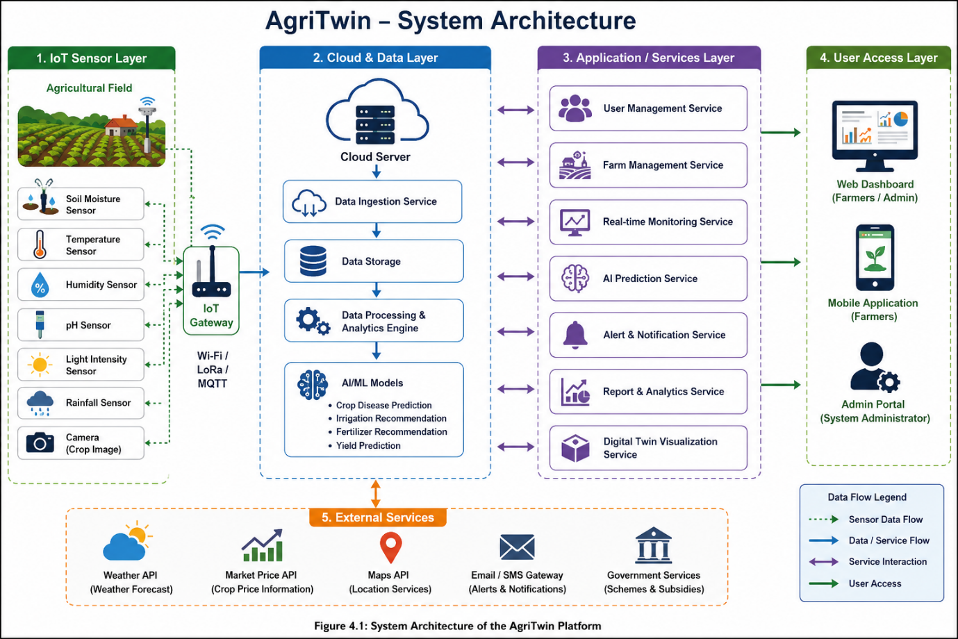

CHAPTER-5
CONCLUSION AND FUTURE SCOPE
5.1 Project Outcomes
The AgriTwin – Digital Twin Platform for Precision Farming and Crop Health Prediction provides an intelligent solution for modern agriculture by integrating Digital Twin technology, Internet of Things (IoT), Artificial Intelligence (AI), and cloud computing. The proposed system enables real-time monitoring of crop and environmental conditions, allowing farmers to make informed decisions based on accurate data. The platform helps in predicting crop diseases, monitoring soil moisture, recommending irrigation schedules, and suggesting fertilizer usage. By combining these technologies into a single system, AgriTwin improves farming efficiency, reduces resource wastage, and increases crop productivity. The project also promotes precision farming by providing timely alerts and recommendations through a centralized dashboard.

5.2 Future Enhancements

Although the proposed system provides several useful features, there is scope for further improvements in the future. Some possible enhancements include:

• Integration with drone and satellite imagery for advanced crop monitoring.

• Mobile application support for Android and iOS devices.

• Voice-based assistance in regional languages for farmers.

• Blockchain technology for secure agricultural data management.

• Market price prediction and crop selling recommendations.

• Integration with government agricultural schemes and subsidy information.

• Advanced AI models for more accurate disease and yield prediction.

• Support for multiple crop types and large-scale agricultural farms
5.3 Conclusion
Agriculture is becoming increasingly dependent on technology to meet the growing demand for food production while conserving natural resources. Traditional farming methods are often unable to provide continuous monitoring and early detection of crop-related problems. The AgriTwin platform addresses these challenges by combining Digital Twin technology, Artificial Intelligence, IoT sensors, and cloud computing into a single intelligent system. The proposed platform enables real-time crop monitoring, disease prediction, smart irrigation management, and fertilizer recommendations. These features help farmers improve crop yield, reduce farming costs, and make better decisions based on real-time information. The system also supports sustainable and precision farming practices by minimizing the unnecessary use of water, fertilizers, and pesticides. Overall, AgriTwin demonstrates how modern software engineering technologies can be applied to agriculture to improve productivity, efficiency, and sustainability. With future enhancements, the platform has the potential to become a comprehensive smart farming solution that benefits farmers, agricultural organizations, and society.

in ensuring data security, fast access, and reliable storage management. The project also highlights the role of advanced file system technologies in supporting cloud computing, enterprise systems, and large-scale data processing. The knowledge gained from this study is beneficial for students, researchers, software developers, and system administrators involved in operating systems and storage management technologies.

CHAPTER-7

References
1. Ian Sommerville, *Software Engineering*, 10th Edition, Pearson Education.
2. Roger S. Pressman and Bruce R. Maxim, *Software Engineering: A Practitioner's Approach*, McGraw-Hill.
3. Food and Agriculture Organization (FAO). *Digital Agriculture and Smart Farming*.
4. IEEE Xplore Digital Library – Research papers on IoT and Precision Agriculture.
5. Google Cloud Documentation – IoT and Cloud Services.
6. TensorFlow Documentation – Machine Learning for Crop Disease Prediction.
7. Research articles on Digital Twin Technology for Smart Agriculture.

